PHASE-2

Project Title: Transfroming healthcare with AI-Powered disease prediction based on patient data.
Github link:
https://github.com/Lakspriya-2005/Transforming-healthcare-with-AI-powered-disease-prediction-based-on-patient- data..git

Problem Statement

  - Healthcare systems often struggle to predict diseases early due to lack of integrated data analysis. Manual diagnosis can be time-consuming and error-prone. By leveraging AI to predict diseases using patient data, healthcare providers can identify conditions early, improve treatment plans, and enhance patient outcomes.

  - This project focuses on building a machine learning model to predict the presence or risk level of a specific disease using patient demographic, lifestyle, and clinical attributes.

  - Significance: Enables preventive care, reduces healthcare costs, and improves quality of life.

Project Objectives

  - Develop a predictive model that identifies potential diseases based on patient data.

  - Improve diagnostic efficiency using machine learning algorithms.

  - Deliver actionable insights to assist healthcare professionals in decision-making.

  - Enhance early detection and prevention strategies.

  - Build an accurate AI model for disease prediction.

  - Identify the key features influencing disease risk.
  - Interpret model outputs to guide clinical decisions.

  - Deploy a user-friendly web interface for real-time predictions.

  - Ensure ethical AI practices and patient data privacy

Flowchart of the Project Workflow

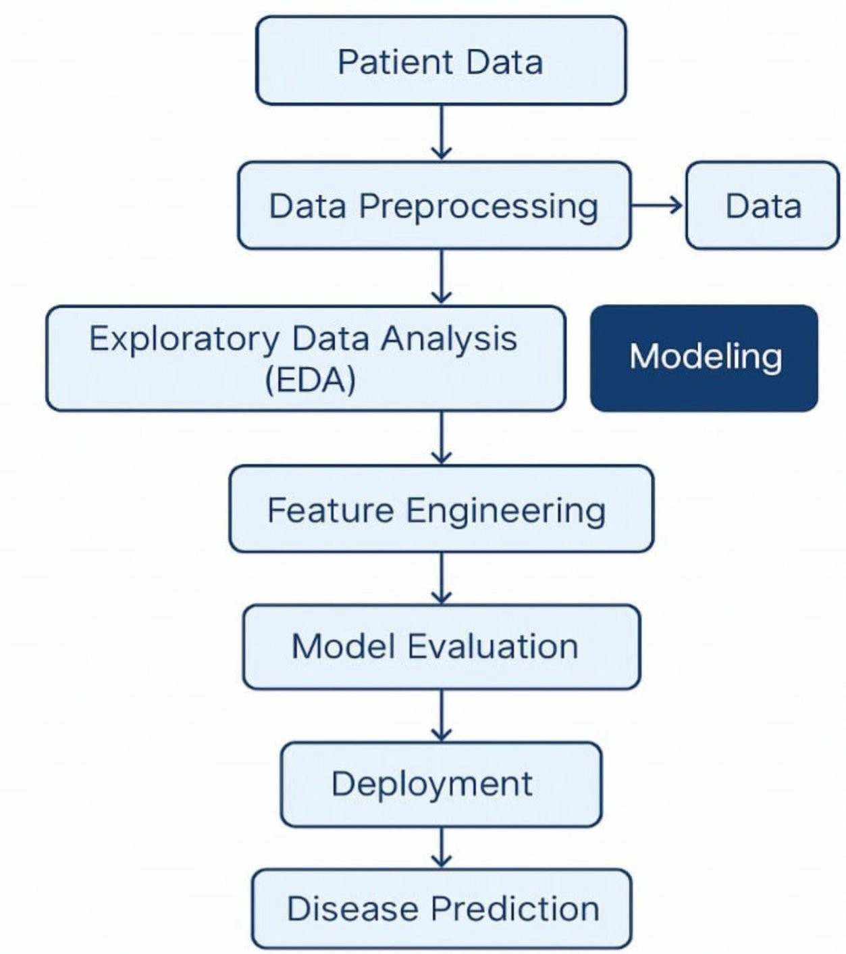
- Data Description

Dataset Name:
Could be sourced from open healthcare datasets.

Source:

Public repositories like UCI, Kaggle, or hospital collaborations.

Data Type:
Structured tabular (e.g., CSV).

Records and Features:
1,00–100,0 records with 10–50 features.

Target Variable:
Presence/absence or probability of diseases.(e.g.,stroke)

Features:
id,Age, gender, hypertension,heart disease,work type,bmi,even married,smoking status ,stroke,etc..
  - Dataset link: https://www.kaggle.com/code/manarmohamed11/stroke-prediction- eda?scriptVersionId=236663015&cellId=2

Data Preprocessing

  - Handle missing/null values.
  - Convert categorical variables via one-hot encoding or label encoding.

  - Scale numerical features using StandardScaler/MinMaxScaler.

  - Remove or cap outliers (using z-scores or IQR).

  - Address imbalanced data using SMOTE, oversampling, or class weights.

Exploratory Data Analysis (EDA)

Univariate:
Distribution of disease status, age, BMI, etc.

Bivariate:
Compare features (e.g., glucose vs. disease outcome).

Multivariate:
Correlation heatmaps, risk factor clusters.

Key Insights:

    - High cholesterol, older age, and sedentary lifestyle may correlate with higher disease risk.

    - Gender-specific trends may exist in disease occurrence.

Feature Engineering

  - Create composite indicators (e.g., BMI from weight & height).

  - Derive binary flags (e.g., smoker = yes/no).

  - Remove redundant or highly correlated features.

  - Encode interaction effects (e.g., age × cholesterol).

Model Building

Algorithms:
    - Logistic Regression: baseline model.
    - Random Forest / XGBoost: for non-linear patterns
Neural Networks (optional for large data).

  - Train-Test Split: 80/20 split using train_test_split.

  - Cross-Validation: 5-fold or 10-fold to ensure robustness.

Evaluation Metrics:
    - Accuracy
    - Precision, Recall, F1-score
    - AUC-ROC Curve
    - Confusion Matrix

Visualization of Results & Model Insights

Feature Importance:
    - Visualized via bar charts (Random Forest, SHAP values)

    - Identify top 5–10 contributing factors

Model Performance:
    - Compare evaluation metrics across models
    - ROC curves and confusion matrices for final model

Residual Analysis:
    - Check for prediction bias (e.g., gender, ethnicity)

Deployment & Interface

Tool:
Gradio or Streamlit

Features:
    - Input patient data via sliders/forms
    - Get real-time disease prediction and risk score
    - Display risk explanation (via SHAP or LIME)

Tools and Technologies Used

Language:
Python

Environment:
Google Colab, Jupyter Notebook

Libraries:
    - pandas, numpy – Data handling
    - matplotlib, seaborn, plotly – Visualization
    - scikit-learn, xgboost, shap – Modeling
    - gradio, streamlit – UI deployment

Team Members and Contributions

  - Clearly mention who worked on:

V.SANGEETHA:
      - Data cleaning

C.NITHYAPRIYA:
      - EDA (Exploratory Data Analysis)

S.K.LAKSHMIPRIYA:
      - Feature engineering

S.MAHALAKSHMI
      - Model development
      - Documentation and reporting

